ShelfSight:Merchandising Assistant
Project Description:
ShelfSight is a Generative AI application that helps retail teams turn a photo of a store shelf into a consistent, actionable merchandising review. A store manager or employee uploads a shelf photo, and ShelfSight uses Google's Gemini multimodal vision model to describe what the photo actually shows - product visibility, shelf organization, empty or underused space, product grouping, promotional visibility, shelf balance and possible misplaced products - and turns those observations into a scored, structured shelf analysis with concrete recommendations.
Beyond reviewing a shelf that already has products, ShelfSight also plans where products should go on an empty shelf or fixture, and lets a manager compare shelf photos over time to track whether earlier recommendations actually improved the shelf. The application is built as a Streamlit workspace with an English, Telugu and Hindi interface, and every AI call is backed by a clearly labeled demo fallback so the app keeps working even without a live Gemini key or during a temporary quota limit.
Scenarios:
Scenario 1: A store manager opens Check My Shelf, uploads a photo of a stocked shelf, picks a goal such as Reduce Empty Space, and selects the shelf section. ShelfSight sends the photo to Gemini with a schema-constrained prompt and returns five 0-100 scores (overall, visibility, organization, space utilization, presentation), a plain-English summary, a list of detected issues with evidence and recommendations, and a color-coded visual overlay highlighting exactly which shelf rows need attention.
Scenario 2: During a busy period the Gemini API quota is temporarily exhausted. Instead of failing, ShelfSight detects the quota error, keeps the manager's uploaded photo, and returns a clearly labeled demo analysis - "Demo mode: Sample analysis shown because Gemini API is temporarily busy" - so the manager can still see how the workflow behaves.
Scenario 3: A manager preparing a new snack display opens Plan New Shelf, uploads a photo of the empty fixture, sets it to 4 shelf levels, and selects the categories to stock - Biscuits, Chocolates, Chips, Cookies and Drinks. ShelfSight returns a placement plan explaining which level suits each category and why, drawn directly onto the manager's own photo. After restocking, the manager returns to Check My Shelf to re-scan the same shelf, and Store Progress shows the before-and-after photos side by side with the score change.
Technical Architecture:
Streamlit Frontend (app.py - routing, session state, multilingual UI)
↓
Demo Authentication (session-only, no real verification)
↓
Vision Analysis Service (services/vision_analyzer.py - Gemini multimodal calls)
↓
Pydantic Schema Layer (models/shelf_analysis.py)
↓
Visualization Components (components/shelf_planner.py, components/analysis_results.py)
↓
Config & Model Fallback (utils/config.py - GEMINI_API_KEY, GEMINI_MODEL)

assets/images/ (optional local retail photography, falls back to Unsplash) | .env (GEMINI_API_KEY, optional GEMINI_MODEL)
Description:
The application follows a layered design centred on a single Streamlit entrypoint, app.py, which configures the page, injects a custom design system, bootstraps session state, and routes between four pages: Home, Check My Shelf, Plan New Shelf and Store Progress (Store Evolution internally). A t() helper resolves interface text from a LANGUAGE_TEXT dictionary covering English, Telugu and Hindi, so the whole workspace can switch language from a selector on the Home page.
services/vision_analyzer.py holds the Generative AI logic. analyze_shelf() and analyze_empty_shelf() each build a plain-English, schema-constrained prompt, call the Gemini API with the Pydantic model's JSON schema as the response schema, and validate the returned JSON back into a ShelfAnalysis or EmptyShelfPlan object. Both functions try a configured model and a fallback list of alternate Gemini models, classify failures (quota exhaustion, model unavailability, transient errors), retry transient failures with increasing delays, and fall back to a deterministic, clearly labeled demo result rather than ever showing the manager a raw error. components/shelf_planner.py and components/analysis_results.py turn the validated data into Pillow-rendered images and Streamlit-rendered HTML cards.
(Note: ShelfSight's Sign In and Create Account forms are a visual, session-only gate - the Sign In form is pre-filled with a placeholder email and password, and submitting either form simply marks the session authenticated without checking any credential against a stored account. See Limitations for the implications of this.)
Key Functions & Modular Components:
- Shelf Analysis Service (services.vision_analyzer.analyze_shelf): sends an uploaded shelf photo and the selected goal to Gemini with a JSON schema-constrained prompt and returns a validated ShelfAnalysis.
- Empty Shelf Planning Service (services.vision_analyzer.analyze_empty_shelf): sends an uploaded empty-shelf photo, shelf-level count and selected categories to Gemini and returns a validated EmptyShelfPlan.
- Error Classification and Demo Fallback (services.vision_analyzer): AnalysisError plus _is_quota_error(), _is_model_unavailable() and _is_transient_error() classify Gemini failures; build_demo_analysis() and build_demo_empty_plan() supply clearly labeled sample results when Gemini is unavailable.
- Configuration and Model Fallback (utils.config): loads GEMINI_API_KEY and an optional GEMINI_MODEL from .env, and gemini_models_to_try() returns a deduplicated list of models to attempt, led by DEFAULT_GEMINI_MODEL (gemini-flash-lite-latest).
- Shelf Analysis Schema (models.shelf_analysis.ShelfAnalysis): Pydantic model for five 0-100 scores, detected issues, recommendations, priority actions, a summary and per-row shelf detail (ShelfRow, ShelfProduct, EmptySpace).
- Empty Shelf Planning Schema (models.shelf_analysis.EmptyShelfPlan): Pydantic model for a shelf-level count, a summary, and a CategoryPlacement per stocked category (recommended zone, reason, tip).
- Shelf Planner Rendering (components.shelf_planner): Pillow-based rendering - the current-vs-recommended overlay, the empty-shelf placement image, a vertical zone guide, a shelf heatmap and a what-if scenario comparison, plus the score_values() and scenario_scores() helpers behind them.
- Analysis Results Cards (components.analysis_results.render_analysis_results): renders a ShelfAnalysis as score cards with plain-English explanations plus severity-sorted issue and recommendation cards.
Pre-requisites:
- Python Programming Proficiency: Python Documentation
- Streamlit Framework Knowledge: Streamlit Documentation
- Google Gemini API Familiarity: Gemini API Documentation
- Gemini Multimodal (Image) Input: Gemini Image Understanding Guide
- Gemini Structured Output: Gemini Structured Output Guide
- Gemini API Key Setup: Google AI Studio API Keys
- Pydantic Schema Validation: Pydantic Documentation
- Image Processing with Pillow: Pillow Documentation
- Environment Variable Handling: python-dotenv Documentation
- Version Control with Git: Git Documentation
Project Workflow:
Milestone 1: Project Setup and Environment Configuration
- Activity 1.1: Install the project dependencies from requirements.txt.
- Activity 1.2: Configure the Gemini API key and model in .env.
- Activity 1.3: Configure .gitignore and the optional local assets directory.
Milestone 2: Shelf Analysis Data Models
- Activity 2.1: Define the component models (DetectedIssue, Recommendation, EmptySpace, ShelfProduct, ShelfRow).
- Activity 2.2: Define the composite ShelfAnalysis model.
- Activity 2.3: Define the CategoryPlacement and EmptyShelfPlan models.
Milestone 3: Gemini Vision Analysis for Stocked Shelves
- Activity 3.1: Engineer the plain-English shelf analysis prompt.
- Activity 3.2: Generate structured JSON against the ShelfAnalysis schema.
- Activity 3.3: Try a configured model with a fallback model list.
Milestone 4: Error Handling, Quota Detection and Demo Fallback
- Activity 4.1: Classify Gemini failures with AnalysisError.
- Activity 4.2: Translate failures into plain-English, user-facing messages.
- Activity 4.3: Build a clearly labeled demo analysis and demo empty-shelf plan.
Milestone 5: Empty Shelf Placement Planning
- Activity 5.1: Engineer the empty-shelf placement prompt.
- Activity 5.2: Generate a structured EmptyShelfPlan, with a rule-based demo fallback.
Milestone 6: Streamlit Application Foundation
- Activity 6.1: Configure the Streamlit page and multilingual text system.
- Activity 6.2: Apply the custom design system.
- Activity 6.3: Bootstrap session state.
- Activity 6.4: Build the session-only Sign In and Create Account forms.
Milestone 7: Home and Check My Shelf Pages
- Activity 7.1: Build the Home page and language selector.
- Activity 7.2: Build the Check My Shelf upload, goal and analysis flow.
Milestone 8: Visual Analysis Results Rendering
- Activity 8.1: Render the current-vs-recommended visual overlay.
- Activity 8.2: Render scores, written findings and recommendation cards.
Milestone 9: Plan New Shelf and Store Progress Pages
- Activity 9.1: Build the Plan New Shelf upload, levels and category flow.
- Activity 9.2: Build the Store Progress before-and-after comparison.
Milestone 10: Deployment, Testing and Conclusion
- Activity 10.1: Run the application locally with Streamlit.
- Activity 10.2: Verify current end-to-end behavior, including demo mode.
Milestone 1: Project Setup and Environment Configuration
This milestone prepares the local environment so ShelfSight can call the Gemini API and knows where to find optional local product photography.
Activity 1.1: Install the Project Dependencies
requirements.txt lists five pinned-minimum dependencies covering the UI, the Gemini SDK, environment loading, image processing and schema validation.
streamlit>=1.36.0
google-genai>=1.0.0
python-dotenv>=1.0.0
Pillow>=10.0.0
pydantic>=2.0.0
requirements.txt - the project's dependencies
streamlit provides the web framework, google-genai is the client library for Gemini's multimodal vision models, python-dotenv loads the .env file, Pillow renders the shelf overlays and placement images, and pydantic validates every AI response against a strict schema before it reaches the UI.
Activity 1.2: Configure the Gemini API Key and Model
utils/config.py loads a .env file from the project root with python-dotenv, then resolves which Gemini model to use. GEMINI_MODEL is optional - if it is not set, DEFAULT_GEMINI_MODEL ("gemini-flash-lite-latest") is used, chosen specifically because it is proven to work with image input and structured JSON output, unlike gemini-2.5-flash which the code notes returns 404 for some newer API keys.
PROJECT_ROOT = Path(__file__).resolve().parent.parent
ENV_PATH = PROJECT_ROOT / ".env"
load_dotenv(dotenv_path=ENV_PATH)

# Proven with google-genai 2.24.0: image input + structured JSON.
# gemini-2.5-flash is listed for some keys but returns 404 for new users.
DEFAULT_GEMINI_MODEL = "gemini-flash-lite-latest"

configured_model = os.getenv("GEMINI_MODEL", "").strip()
GEMINI_MODEL = configured_model or DEFAULT_GEMINI_MODEL
utils/config.py - resolving the Gemini model to use
get_gemini_api_key() reads and strips GEMINI_API_KEY, and is_gemini_configured() returns whether a non-empty key is present. A developer creates a .env file in the project root with GEMINI_API_KEY set to a real key, and optionally GEMINI_MODEL to override the default.
Activity 1.3: Configure .gitignore and the Assets Directory
.gitignore excludes the local .env file and Python cache artifacts (__pycache__/, *.pyc), so the Gemini API key is never committed. The assets/images/ directory is reserved for optional, high-resolution retail photography (retail_hero.jpg, retail_login.jpg, retail_store.jpg, retail_shelf.jpg, and five category photos); if a given file is not present locally, the application falls back to a matching remote Unsplash photograph automatically, so the interface always has imagery.
.env
__pycache__/
*.pyc
.gitignore - excluded files
Milestone 2: Shelf Analysis Data Models
models/shelf_analysis.py defines every shape of data Gemini is allowed to return, using Pydantic so a malformed or incomplete AI response is rejected before it ever reaches the interface.
Activity 2.1: Component Models
DetectedIssue and Recommendation share a Severity type restricted to "Low", "Medium" or "High". ShelfProduct and EmptySpace describe individual items Gemini can identify on a shelf row, and ShelfRow groups them under a vertical zone restricted to Top, Eye Level, Hand Level, Lower Level or Unclear.
Severity = Literal["Low", "Medium", "High"]

class DetectedIssue(BaseModel):
issue: str = Field(min_length=1)
severity: Severity
evidence: str = Field(min_length=1)
recommendation: str = Field(min_length=1)

class ShelfProduct(BaseModel):
label: str = Field(min_length=1)
approximate_position: str = Field(default="unclear", min_length=1)
group: str = Field(default="Product Group", min_length=1)
facing_count: int | None = Field(default=None, ge=1)
visibility: str = Field(default="visible", min_length=1)

class ShelfRow(BaseModel):
row_number: int = Field(ge=1)
vertical_zone: Literal["Top", "Eye Level", "Hand Level",
"Lower Level", "Unclear"] = "Unclear"
products: list[ShelfProduct] = Field(default_factory=list)
empty_spaces: list[EmptySpace] = Field(default_factory=list)
models/shelf_analysis.py - component models
Activity 2.2: The ShelfAnalysis Model
ShelfAnalysis is the schema Gemini's response is constrained to when analyzing a stocked shelf. Five separate 0-100 scores are captured (overall, visibility, organization, space utilization, presentation) alongside detected products, issues, general recommendations, a shorter priority_actions list, a plain-English summary, and the optional row-by-row shelf_rows breakdown used to draw the visual overlay.
class ShelfAnalysis(BaseModel):
overall_score: int = Field(ge=0, le=100)
visibility_score: int = Field(ge=0, le=100)
organization_score: int = Field(ge=0, le=100)
space_utilization_score: int = Field(ge=0, le=100)
presentation_score: int = Field(ge=0, le=100)
detected_products: list[str] = Field(default_factory=list)
detected_issues: list[DetectedIssue] = Field(default_factory=list)
recommendations: list[Recommendation] = Field(default_factory=list)
priority_actions: list[Recommendation] = Field(default_factory=list)
summary: str = Field(min_length=1)
shelf_rows: list[ShelfRow] = Field(default_factory=list)
models/shelf_analysis.py - the ShelfAnalysis model
Activity 2.3: The Empty Shelf Planning Models
CategoryPlacement pairs a product category with a recommended shelf zone (again restricted to a fixed set of literal values, this time including Bottom), a reason, and a short tip. EmptyShelfPlan wraps a list of these placements together with the shelf's level count and a summary.
class CategoryPlacement(BaseModel):
category: str = Field(min_length=1)
recommended_zone: Literal["Top", "Eye Level", "Hand Level",
"Lower Level", "Bottom"] = "Eye Level"
reason: str = Field(min_length=1)
tip: str = Field(default="", min_length=0)

class EmptyShelfPlan(BaseModel):
shelf_count: int = Field(default=4, ge=1)
summary: str = Field(min_length=1)
placements: list[CategoryPlacement] = Field(default_factory=list)
models/shelf_analysis.py - the empty-shelf planning models
Milestone 3: Gemini Vision Analysis for Stocked Shelves
analyze_shelf() in services/vision_analyzer.py is the core Generative AI workflow for a shelf that already has products on it.
Activity 3.1: The Shelf Analysis Prompt
ANALYSIS_PROMPT assigns Gemini the role of a friendly helper for a store employee and lists nine things to evaluate - product visibility, organization, facing consistency, empty space, grouping, promotional visibility, shelf balance, possible misplacement, and overall merchandising quality. The prompt is deliberately written to keep the output usable by non-specialists: it explicitly forbids merchandising jargon ("facings", "planogram", "gondola", "category blocks") in favor of plain phrases, and it repeatedly instructs the model to describe only what is visibly present rather than inventing products, prices, or sales performance.
You are ShelfSight, a friendly helper for a store manager or store
employee. Use simple, clear, everyday English.

Analyze the uploaded supermarket shelf photograph. Base every
observation ONLY on what is visibly present in the image. Do not
invent products, prices, empty spaces, or problems that cannot
reasonably be observed.

Evaluate: 1. Product visibility 2. Shelf organization
3. Product facing consistency 4. Empty or underutilized shelf space
5. Product grouping 6. Promotional visibility 7. Shelf balance
8. Possible misplaced products 9. Overall merchandising quality

The user selected this objective: {selected_goal}
Focus the recommendations particularly on this objective.

Return only valid JSON matching the supplied schema.
services/vision_analyzer.py - ANALYSIS_PROMPT (excerpt)
Activity 3.2: Structured JSON Generation
_generate_with_model() sends the uploaded image bytes as a types.Part alongside the formatted prompt, with response_mime_type set to application/json and response_schema set to ShelfAnalysis's own JSON schema. temperature is kept low (0.2) to favor consistent, grounded output over creative variation, and automatic function calling is explicitly disabled since no tool use is needed. The returned text is stripped of any Markdown code-fence wrapper and parsed with ShelfAnalysis.model_validate(), so a response that does not match the schema raises an AnalysisError rather than reaching the UI.
response = client.models.generate_content(
model=model,
contents=[
types.Part.from_bytes(data=image_bytes, mime_type=mime_type),
ANALYSIS_PROMPT.format(selected_goal=selected_goal),
],
config=types.GenerateContentConfig(
response_mime_type="application/json",
response_schema=_analysis_schema(),
temperature=0.2,
automatic_function_calling=types.AutomaticFunctionCallingConfig(
disable=True),
),
)
return _parse_analysis(_response_text(response))
services/vision_analyzer.py - _generate_with_model(): schema-constrained multimodal generation
Activity 3.3: Model Fallback and Retries
gemini_models_to_try() (from utils/config.py) returns a deduplicated list starting with the configured GEMINI_MODEL, followed by GEMINI_MODEL_FALLBACKS (gemini-flash-lite-latest, gemini-3.5-flash-lite, gemini-3.5-flash, gemini-flash-latest). analyze_shelf() loops over this list and, for each model, retries up to MAX_RETRIES (3) times with increasing delays (2, 5, then 10 seconds) whenever a failure looks transient, before moving on to the next model in the list. Input is validated up front - an empty upload, a file over 20 MB, or a file Pillow cannot open as an image are all rejected immediately with a clear message, before any Gemini call is attempted.
MAX_RETRIES = 3
RETRY_DELAYS_SECONDS = (2, 5, 10)

for model_index, model in enumerate(models):
for attempt in range(MAX_RETRIES + 1):
try:
analysis = _generate_with_model(client, model, image_bytes,
mime_type, selected_goal)
return analysis, "gemini"
except Exception as exc:
...
services/vision_analyzer.py - analyze_shelf(): the model-fallback and retry loop
Milestone 4: Error Handling, Quota Detection and Demo Fallback
Milestone 4 covers how ShelfSight tells different kinds of Gemini failure apart, and why a failure almost never reaches the manager as a raw error.
Activity 4.1: Classifying Gemini Failures
AnalysisError carries flags for whether the failure is retryable, whether it was a quota exhaustion, and whether the requested model is unavailable. _is_quota_error() checks for an HTTP 429 status or keywords such as RESOURCE_EXHAUSTED, RATE LIMIT or QUOTA. _is_model_unavailable() checks for a 404 status or phrases such as NOT_FOUND or "not available to new users". _is_transient_error() treats network timeouts and 500-range server errors as safe to retry, while explicitly excluding quota and model-unavailability errors, which are handled differently rather than simply retried.
def _is_quota_error(exc: Exception) -> bool:
code = _error_code(exc)
if code == 429:
return True
message = _safe_exception_message(exc).upper()
return any(marker in message for marker in
("RESOURCE_EXHAUSTED", "RATE LIMIT", "RATE_LIMIT", "QUOTA"))
services/vision_analyzer.py - _is_quota_error()
Activity 4.2: Plain-English, User-Facing Messages
_user_error_message() converts a classified exception into a short, reassuring message rather than a technical one - for example, a quota error becomes "AI analysis is temporarily unavailable... Your shelf photo is saved. A clearly labeled demo analysis can still be used for the rest of the walkthrough." _safe_exception_message() also redacts the configured API key from any exception text before it is logged or shown, so a key never leaks into an error message.
Activity 4.3: The Clearly Labeled Demo Fallback
When Gemini is not configured at all, when its quota is exhausted, or when every configured model is unavailable, build_demo_analysis() and build_demo_empty_plan() return a deterministic, realistic-looking result instead of an error. Every demo ShelfAnalysis carries a summary that states outright it is a demo ("This is a demo analysis because Gemini is temporarily unavailable... It is not a real reading of this photo."), and the source value returned alongside it ("demo" instead of "gemini") is what the Check My Shelf page checks before showing its own on-screen demo notice.
DEMO_NOTICE = "Demo analysis — Gemini temporarily unavailable"

def build_demo_analysis(selected_goal: str) -> ShelfAnalysis:
...
return ShelfAnalysis(
overall_score=72, visibility_score=68, organization_score=70,
space_utilization_score=64, presentation_score=74,
summary=(
"This is a demo analysis because Gemini is temporarily
unavailable. "
f"The selected goal was {goal}. "
"... It is not a real reading of this photo."
),
...
)
services/vision_analyzer.py - build_demo_analysis(): a clearly labeled sample result
Milestone 5: Empty Shelf Placement Planning
analyze_empty_shelf() answers a different question from analyze_shelf(): not "what is wrong with this stocked shelf" but "where should each product category go on this empty shelf."
Activity 5.1: The Empty Shelf Placement Prompt
EMPTY_SHELF_PROMPT tells Gemini how many shelf levels the fixture has and which product categories the shopkeeper wants to stock, then supplies general merchandising guidance for each vertical zone - premium and impulse items at the top, fast movers at eye level, everyday snacks at hand level, and heavy or bulky items at the bottom - and asks for the best placement per category as JSON matching the EmptyShelfPlan schema.
Analyze the uploaded EMPTY shelf photograph. The shelf has
approximately {shelf_levels} shelf levels.
The shopkeeper wants to stock these product categories: {categories_str}.

Determine the best placement for each selected product category
across the shelf levels:
- Top level: Best for premium items, impulse boxes, chocolates, cookies.
- Eye level: Best for fast movers, popular biscuits, high-demand items.
- Hand/Middle level: Best for snacks, chips, everyday essentials.
- Lower/Bottom level: Best for heavy items, large drink bottles, bulk chips.
services/vision_analyzer.py - EMPTY_SHELF_PROMPT (excerpt)
Activity 5.2: Generating and Falling Back on the Plan
analyze_empty_shelf() follows the same shape as analyze_shelf(): if Gemini is not configured, it returns build_demo_empty_plan() immediately; otherwise it tries each model in gemini_models_to_try() in turn, and if every attempt fails it falls back to the same rule-based demo plan rather than raising. Unlike the AI path, build_demo_empty_plan() is entirely rule-based: a fixed zones_by_category mapping (for example, Chocolates and Cookies to Top, Drinks to Bottom, Snacks and Chips to Hand Level) is adjusted to whichever zones actually exist for the chosen shelf-level count, so even the offline fallback gives sensible, merchandising-informed placements.
zones_by_category = {
"Chocolates": ("Top", "Chocolates at top level catch impulse
attention and look attractive.", "Keep neat facing forward."),
"Drinks": ("Bottom", "Cold or bottled drinks on the bottom shelf
provide stable support for heavy bottles.", "Align bottles neatly."),
"Snacks": ("Hand Level", "Snacks at hand level are quick and easy
to pick up.", "Group similar snack packs together."),
...
}
services/vision_analyzer.py - build_demo_empty_plan(): rule-based fallback placements
Milestone 6: Streamlit Application Foundation
app.py is the single-file Streamlit entrypoint. This milestone covers its page configuration, multilingual text system, custom styling, session state, and the session-only sign-in gate.
Activity 6.1: Page Configuration and Multilingual Text
The page is configured once at import time. Interface text is not hard-coded per page - the t(key) helper looks up the current session language in LANGUAGE_TEXT, a dictionary with parallel English ("en"), Telugu ("te") and Hindi ("hi") translations for every label, button and description in the app, and falls back to English if a key or language is missing.
st.set_page_config(
page_title="ShelfSight | Retail Merchandising Intelligence",
page_icon="SS",
layout="wide",
initial_sidebar_state="expanded",
)

def t(key: str) -> str:
return LANGUAGE_TEXT.get(st.session_state.get("language", "en"),
LANGUAGE_TEXT["en"]).get(key, key)
app.py - page configuration and the t() translation helper
Activity 6.2: Custom Design System
inject_styles() injects a large block of custom CSS via st.markdown(..., unsafe_allow_html=True), themeing the workspace with a warm paper-and-ink retail palette, a dark sidebar, action cards, metric panels, placement cards and a full-bleed authentication visual - well beyond Streamlit's default appearance.
Activity 6.3: Session State Bootstrap
init_session() sets a large block of default session-state values the first time the app runs: authentication state, the current page, the uploaded shelf image and its metadata, the selected goal, the current ShelfAnalysis result, an in-memory list of every past analysis (shelf_analyses), the empty-shelf equivalents (image, level count, category selection, resulting plan), and the current interface language.
defaults = {
"authenticated": False, "auth_mode": "login", "page": "Home",
"shelf_image": None, "shelf_goal": "Overall Shelf Review",
"shelf_analysis": None, "shelf_analyses": [],
"empty_shelf_levels": 4,
"empty_shelf_categories": ["Biscuits", "Chocolates", "Chips",
"Cookies", "Drinks"],
"language": "en",
...
}
for key, value in defaults.items():
st.session_state.setdefault(key, value)
app.py - init_session(): session-state defaults
Activity 6.4: Sign In and Create Account
render_auth() presents a Sign In / Create Account card next to a full-bleed retail photograph. The Sign In form's email and password fields are pre-filled with a placeholder value (manager@store.com / masked dots), and submitting either form - Sign In or Create Account - simply sets st.session_state.authenticated = True and moves to Home; neither form checks the entered value against any stored account or credential. This is a visual, session-only gate rather than a real authentication system (see Limitations).
submitted = st.form_submit_button("Sign In →", type="primary",
use_container_width=True)
if submitted:
st.session_state.authenticated = True
st.session_state.page = "Home"
st.rerun()
app.py - render_auth(): the Sign In form does not check the entered credential
Milestone 7: Home and Check My Shelf Pages
Milestone 7 covers the landing page and the primary shelf-review workflow.
Activity 7.1: Home Page
render_home() shows a language selector, a hero headline and copy (translated via t()), and two large action cards - Check My Shelf and Plan New Shelf - each with its own button that routes into that page via session state. A third, secondary panel links into Store Progress.
Activity 7.2: Check My Shelf
render_inspect_shelf() collects a shelf photo (JPG, PNG or WEBP), a review goal (Overall Shelf Review, Improve Product Visibility, Reduce Empty Space, Improve Organization, or Highlight Promotional Products) and a shelf section (Beverages, Snacks, Grocery, Personal Care, Premium Display, or Other). On Analyze, it calls analyze_shelf() inside a live st.status() indicator that updates with the retry/fallback messages the service reports, then saves the result with save_analysis_record() - which appends a timestamped record (image bytes, goal, section, and the ShelfAnalysis) to st.session_state.shelf_analyses, the in-memory history Store Progress later reads from.
with st.status("Analyzing shelf image...", expanded=False) as status:
try:
analysis, source = analyze_shelf(
st.session_state.shelf_image,
st.session_state.shelf_image_mime,
goal,
status_callback=lambda msg: status.update(label=msg),
)
st.session_state.shelf_analysis = analysis
st.session_state.analysis_source = source
save_analysis_record(analysis, st.session_state.shelf_image,
st.session_state.shelf_image_name,
st.session_state.shelf_image_mime, goal,
section)
app.py - render_inspect_shelf(): calling analyze_shelf() and saving the record
Milestone 8: Visual Analysis Results Rendering
Once an analysis is available, Check My Shelf shows the visual overlay first, then the written findings, and finally the numeric scores - deliberately in that order, so the manager sees the actionable picture before the underlying numbers.
Activity 8.1: The Current-vs-Recommended Overlay
render_current_vs_recommended() (components/shelf_planner.py) shows the manager's original photo next to an AI-annotated version built by _create_recommended_image(). For each ShelfRow, _row_guidance() decides a color and label: red "ACTION REQUIRED" when the row has empty_spaces, yellow "CHECK THIS AREA" when the row's issue text mentions patterns such as vertical stacking or disorganization for that zone, and green "NO ISSUE DETECTED" when the row has products and no matching issue. A translucent rectangle in that color, a white guide outline, a text label and - for empty spaces - a directional arrow are drawn onto a transparent overlay and composited onto the original photo, so every highlighted region is grounded in that row's own detected data.
Activity 8.2: Scores, Findings and Recommendations
score_values() extracts the five ShelfAnalysis scores as a labelled set (Shelf Health, Visibility, Organization, Space Utilization, Presentation) for the metric cards shown after the overlay. Separately, components/analysis_results.py provides a complete, reusable rendering path: render_analysis_results() shows the same scores with a plain-English explanation for each one (via _score_explanation(), which varies its wording around a 90-point threshold), then lists every detected issue and recommendation as a severity-sorted HTML card (High before Medium before Low), with all AI-generated text passed through html.escape() first to prevent any injected markup from rendering. The current Check My Shelf page renders its written findings inline in app.py using this same underlying data; render_analysis_results() stands as an available, self-contained alternative rendering of the identical ShelfAnalysis object.
def score_values(analysis: ShelfAnalysis) -> dict[str, int]:
return {"Shelf Health": analysis.overall_score,
"Visibility": analysis.visibility_score,
"Organization": analysis.organization_score,
"Space Utilization": analysis.space_utilization_score,
"Presentation": analysis.presentation_score}
components/shelf_planner.py - score_values(): the five metrics shown to the manager
Milestone 9: Plan New Shelf and Store Progress Pages
Milestone 9 covers planning a not-yet-stocked shelf, and tracking whether earlier recommendations actually improved a shelf over time.
Activity 9.1: Plan New Shelf
render_plan_new_shelf() collects an empty-shelf photo, a shelf-level count (2 to 5, via a slider) and the product categories to stock (a multiselect defaulting to Biscuits, Chocolates, Chips, Cookies and Drinks). On Generate Placement Plan, it calls analyze_empty_shelf() inside a live status indicator, then renders the result with create_empty_shelf_plan_image() - which draws the recommended zones as labelled, color-coded bands directly onto the manager's own uploaded empty-shelf photo, with a legend explaining each category's color - followed by a written Category Placement Instructions card per category (zone, reason and tip).
Activity 9.2: Store Progress
render_store_evolution() reads st.session_state.shelf_analyses, the in-memory history built up by every Check My Shelf run in the current session. With no saved scans it shows an empty state; with exactly one scan it shows that single photo and its Shelf Health Score; with two or more, it compares the two most recent scans side by side as BEFORE and AFTER photos with their timestamps, then reports the earlier score, the latest score, and the signed score delta between them as three metrics. Because this history lives only in Streamlit's session state, it resets whenever the session ends (see Limitations).
previous_record, latest_record = records[-2], records[-1]
previous = analysis_record_to_model(previous_record)
latest = analysis_record_to_model(latest_record)
...
with m_cols[2]: st.metric("Score Delta",
f"{latest.overall_score - previous.overall_score:+d}")
app.py - render_store_evolution(): before-and-after score comparison
Milestone 10: Deployment, Testing and Conclusion
The final milestone covers running the application locally and verifying its behavior end to end, including its offline demo path.
Activity 10.1: Run the Application Locally
With a virtual environment created and activated, dependencies installed and .env populated with a Gemini API key, the application is launched with Streamlit:
python -m venv .venv
.venv\Scripts\Activate.ps1 # Windows (PowerShell)
source .venv/bin/activate # macOS / Linux

pip install -r requirements.txt

# create a .env file in the project root with:
# GEMINI_API_KEY=your_api_key_here

streamlit run app.py
Creating the environment, installing dependencies and running the application
Streamlit starts a local development server (by default at http://localhost:8501) and opens the application in the browser, presenting the Sign In / Create Account screen first.
Activity 10.2: Verify Current End-to-End Behavior
- Language check: switch between English, Telugu and Hindi on the Home page and confirm labels, descriptions and button text update throughout the workspace.
- Shelf analysis check: upload a stocked shelf photo, try each review goal, and confirm the overlay, scores and written findings all reflect the same ShelfAnalysis result.
- Empty shelf check: upload an empty shelf photo, vary the shelf-level count and category selection, and confirm the placement image and category cards update accordingly.
- Store Progress check: scan the same shelf twice in one session and confirm the before/after photos and score delta appear correctly.
- Demo fallback check: run the app with no GEMINI_API_KEY set and confirm both analysis flows still complete, clearly labeled as demo results.
- Input validation check: attempt to analyze without uploading a photo, and upload a very large or non-image file, and confirm each is rejected with a clear message rather than a crash.
Exploring the Application's Pages:
1. Sign In / Create Account
A full-bleed retail photograph alongside a Sign In / Create Account card. Both forms are session-only: submitting either one marks the session authenticated and opens the workspace, without checking the entered value against a stored account.
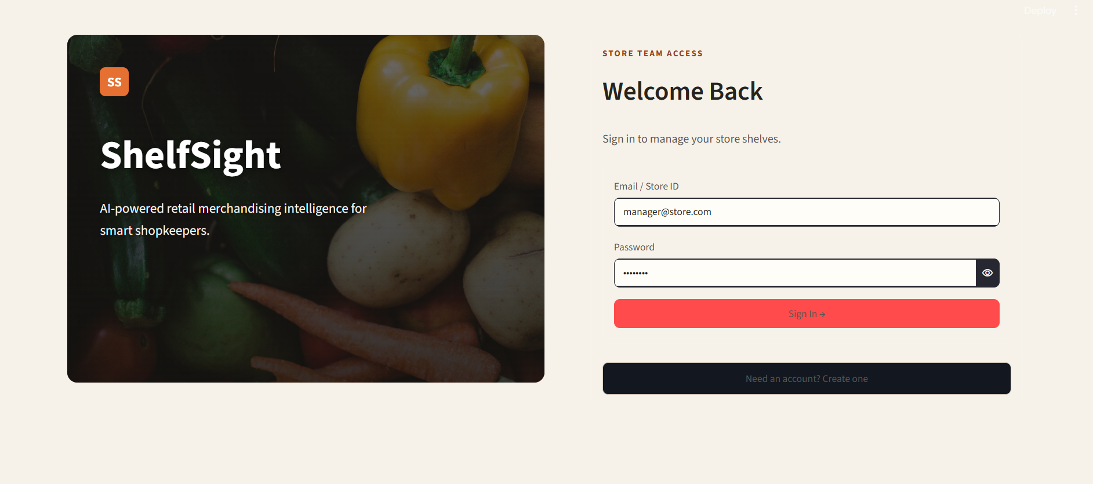
2. Home
A language selector, a hero headline, and two large action cards - Check My Shelf and Plan New Shelf - plus a secondary panel linking into Store Progress.
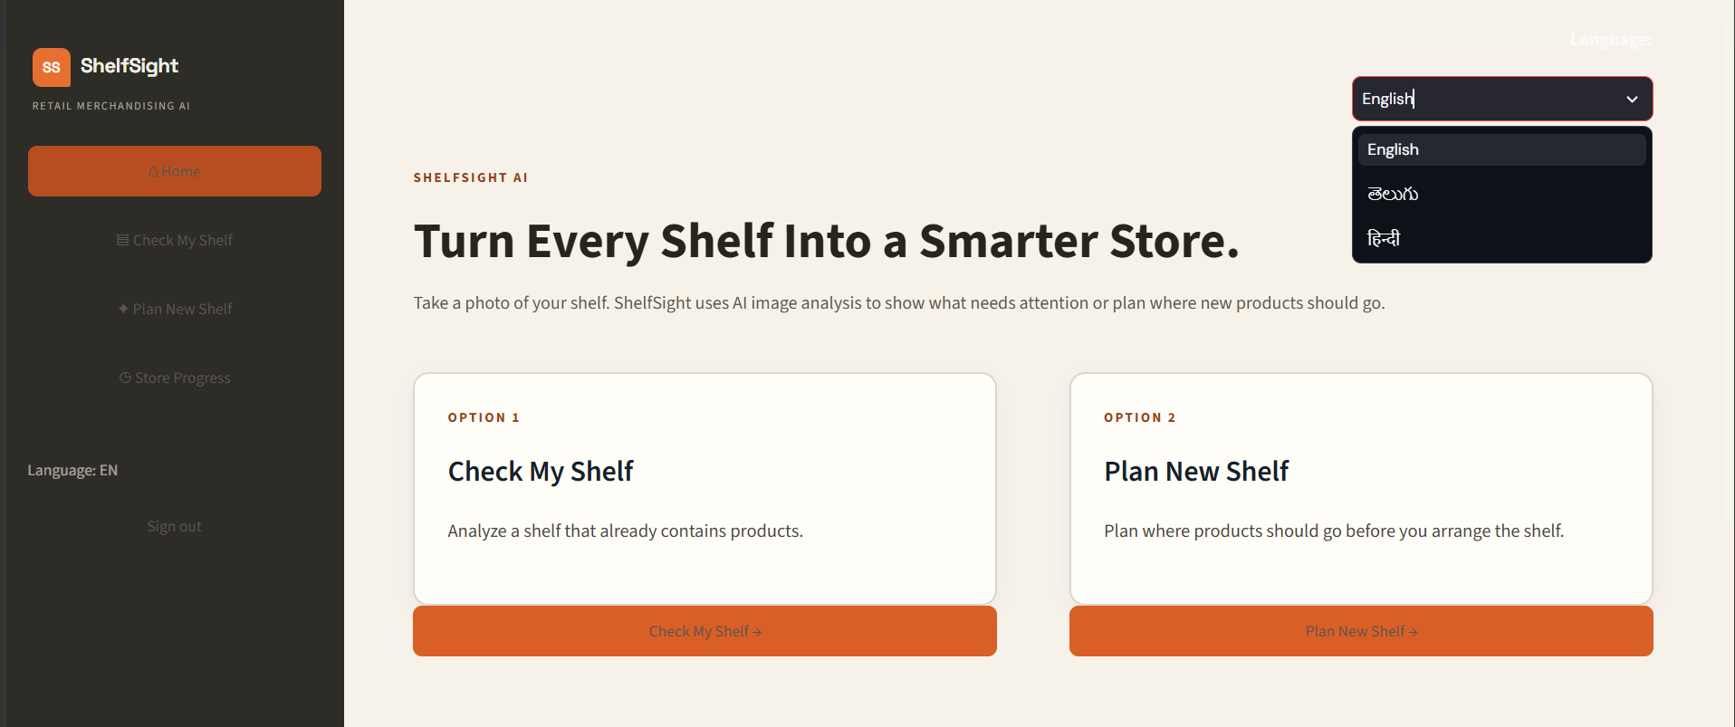
3. Check My Shelf
Upload a stocked shelf photo, choose a review goal and shelf section, and receive a color-coded visual overlay, a written summary with detected issues, and five 0-100 scores from Gemini (or a clearly labeled demo result).
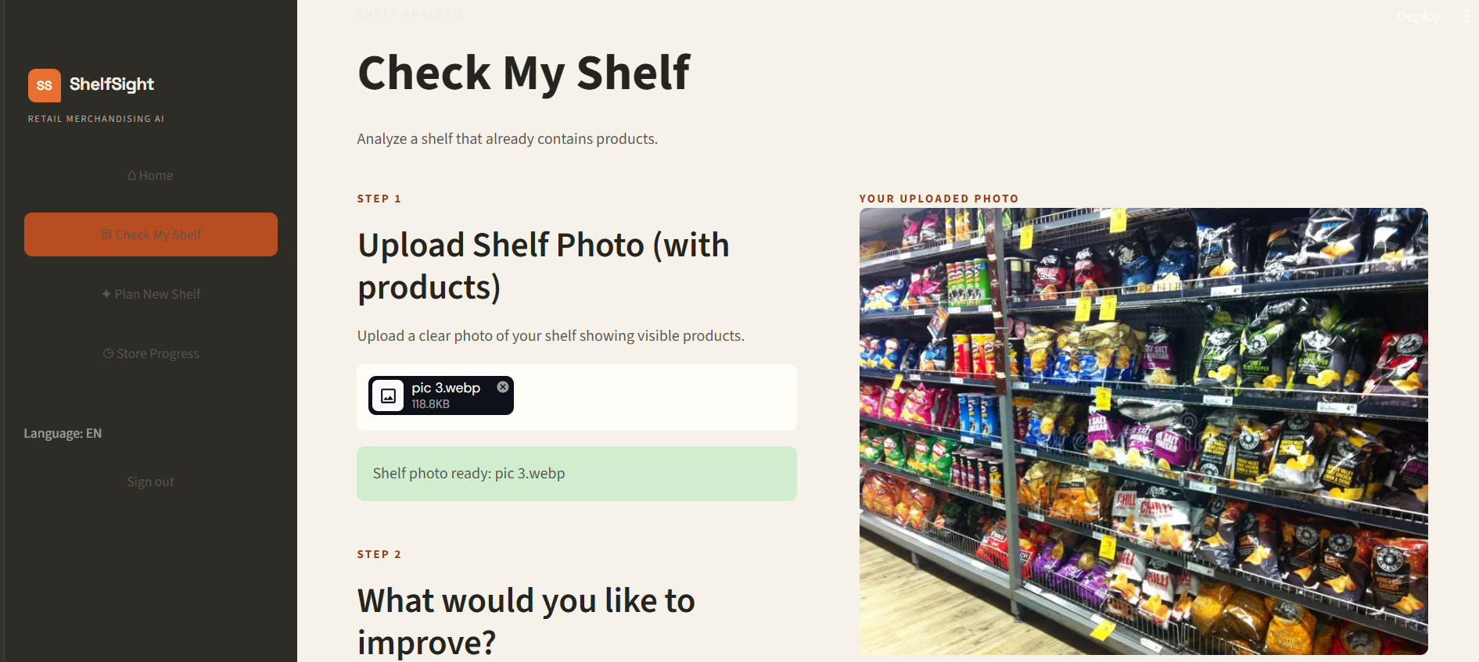
4. Plan New Shelf
Upload an empty shelf photo, set the number of shelf levels and the product categories to stock, and receive a placement plan drawn directly onto the uploaded photo, with a reason and tip for each category's recommended zone.
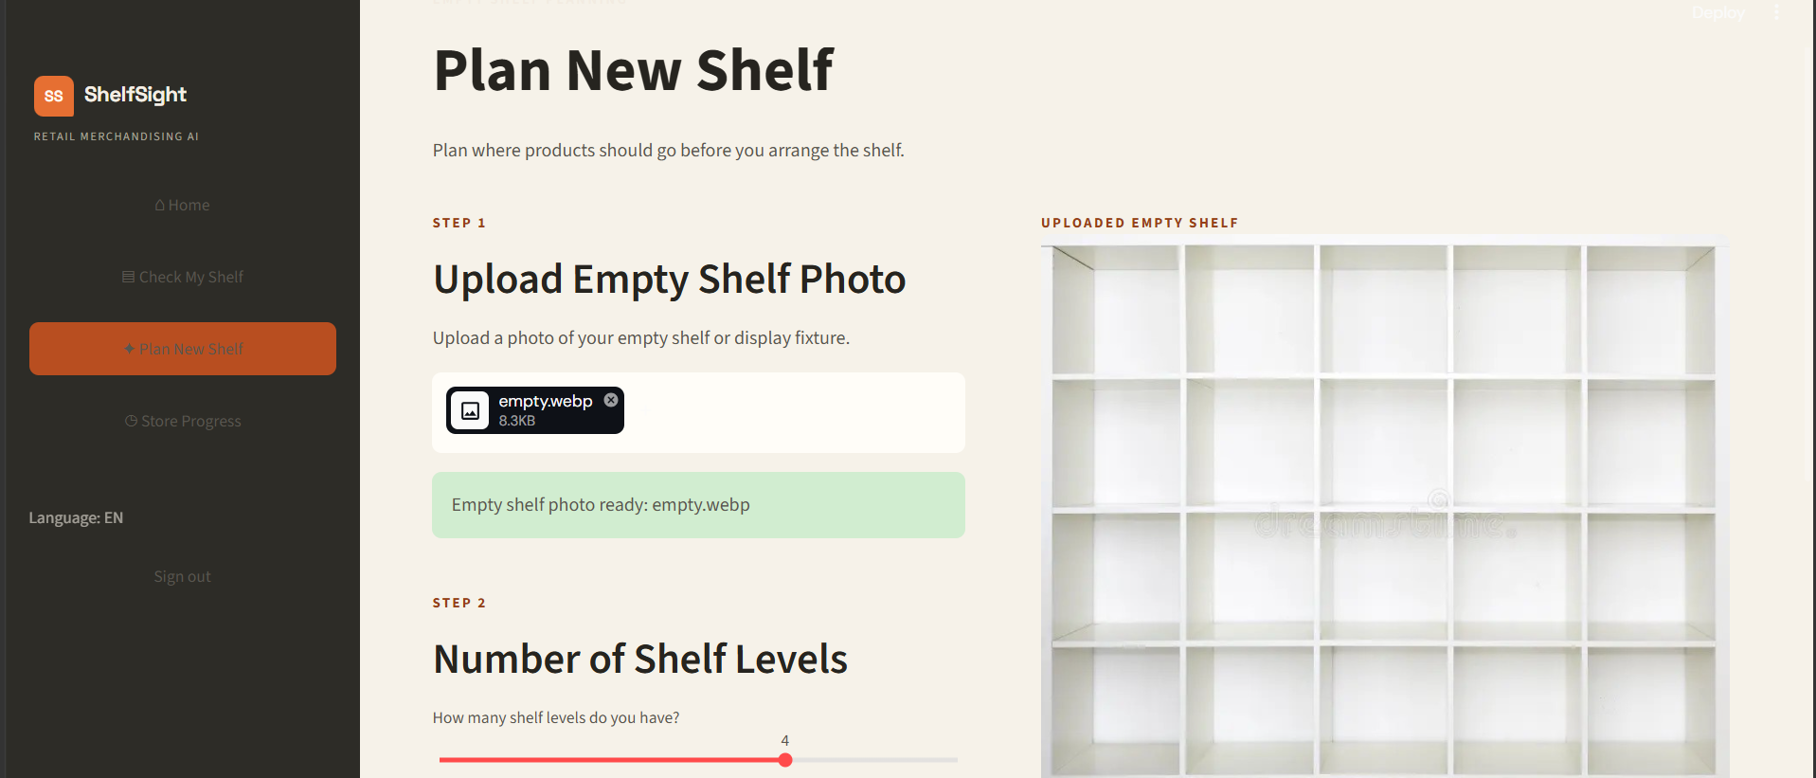
5. Store Progress
Compares the two most recent shelf scans from the current session side by side as before-and-after photos, with the earlier score, the latest score, and the score delta between them.
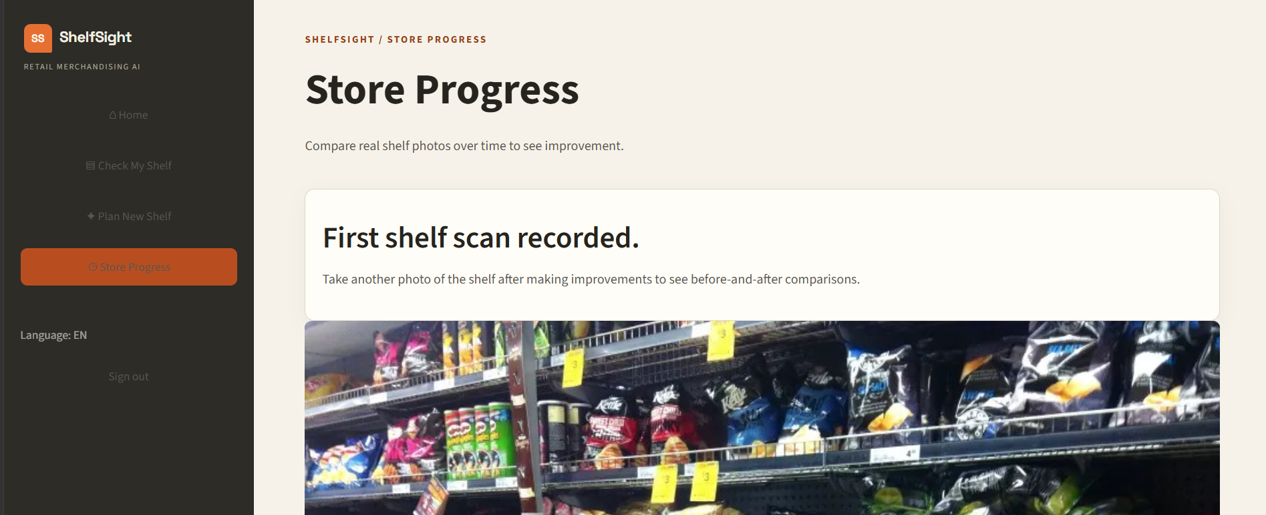
Conclusion:
ShelfSight is a Generative AI application that turns a photo of a retail shelf into a consistent, structured merchandising review. Google's Gemini multimodal vision model analyzes an uploaded shelf photo against a plain-English, schema-constrained prompt and returns five scored dimensions, a written summary, detected issues with evidence and recommendations, and a row-by-row breakdown that a Pillow-rendered overlay turns into a color-coded, at-a-glance action guide - all validated through Pydantic models before ever reaching the interface.
The same underlying approach plans an empty shelf's product placement, and a lightweight in-session history lets a manager compare shelf photos before and after making changes. Every AI call is protected by model fallback, retry logic, and a clearly labeled demo result, so ShelfSight keeps working - honestly, and without ever pretending a sample result is a real reading of a photo - even when Gemini is unavailable. A multilingual interface in English, Telugu and Hindi, and a warm, purpose-built Streamlit design system, complete a workspace built around the everyday reality of a busy store manager reviewing shelves between other tasks.

